1. Bash script to print odd numbers from the list. (12,5,7,10,8,19,20,23,25) 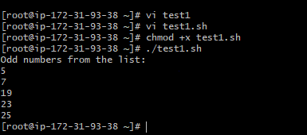 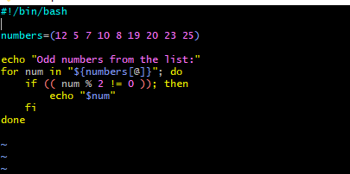
   * numbers=(...) initializes an array with the given numbers.
   * The for loop iterates over each number in the array.
   * if (( num % 2 != 0 )) checks if the number is odd.
   * If the condition is true, the number is printed.
2. Bash script to take a input from user and check if it is greater than or less than 10

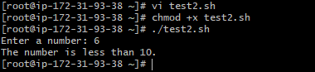

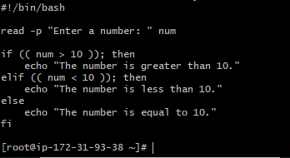

• read -p prompts the user for input.

• if, elif, and else statements compare the input to 10 and print the appropriate message.

1. Bash script to login to multiple servers and check if httpd service is running or not

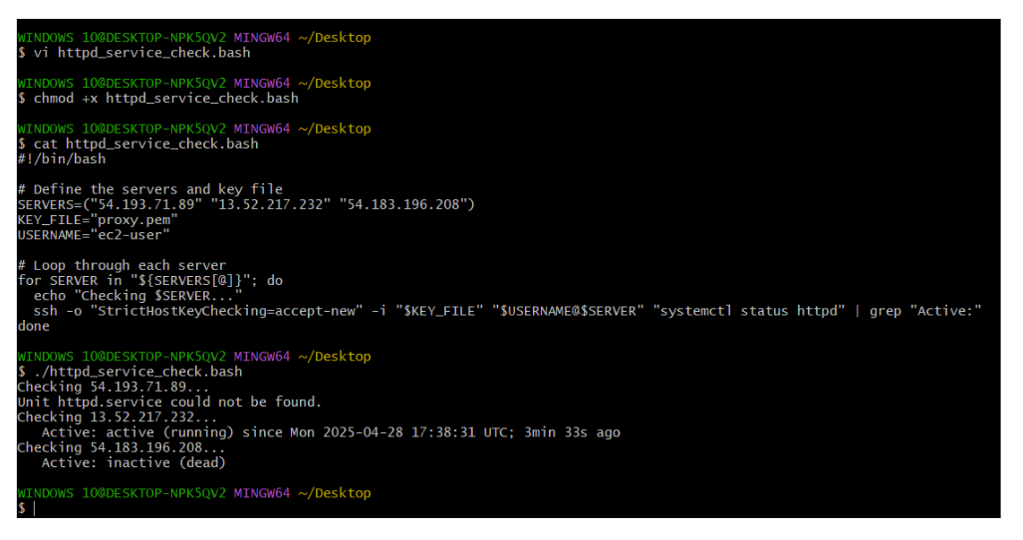

1. Bash script to check the log files from a path and delete files older than 20 days. 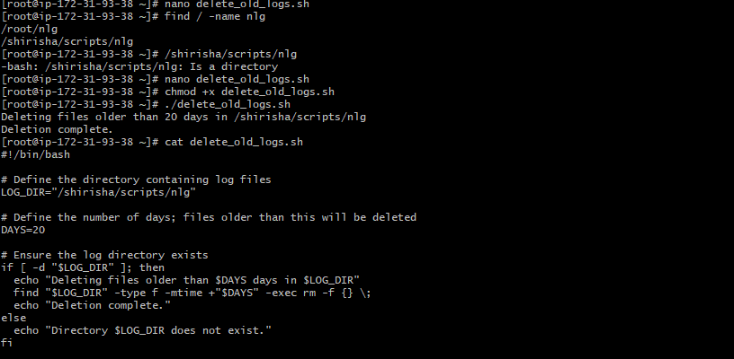
2. Bash script to print 3rd word and 5th word from the given input of user

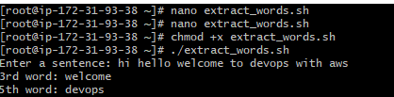

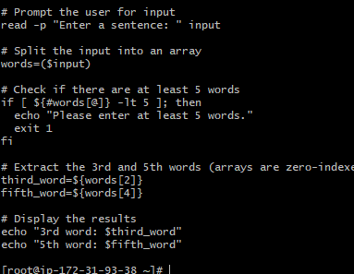

1. Bash script to print numbers between 1 to 100 and then seperate the odd numbers and even numbers

